**CSCI 1411: Fundamentals of Computing**

**Lab 1**

**Due Date: January 26, 2022**

**Name: Malachi Milton-Brewer**

**Goals:**

* Practice ROCkET methodology
* Understand concept of an algorithm (and pseudo-code)

**Development Environment: None.**

**Deliverables:** This completed document. (In either Word or pdf format)

How to take a **screen shot**:

* For a Windows 10: Use Snipping Tool to copy and CTRL + V paste screen shot.
* For Mac: Shift + Command + 4 to copy and CTRL + V to paste screen shot.

**Part I – (2 pts) ROCkET Method**

* Introduce yourself to the person sitting next to you. Write down their name below and one interesting fact about them. Today this person is your lab partner. Every lab you are required to have a lab partner so choose your seats next to the person you want to work with.

|  |
| --- |
| Eddeek Zaid |

* Write down the name of you Lab instructor.

|  |
| --- |
| Masoumeh Abolfathi |

* Put your name below this statement: I understand that I have to attend every lab (or get approval from the instructor) in order to get full credit for each lab.

|  |
| --- |
| Malachi Milton-Brewer |

* ROCkET Methodology
  + **R**ead the entire problem, taking notes and underlining important areas
  + **O**utline the tasks in plain English with enough detail to write code
  + **C(k)**ode small portions at a time
  + **E**valuate each small portion of code. Ensure it compiles AND does what it is supposed to
  + **T**est the entire program. Ensure it compiles AND does everything listed in the outline
* Read this entire lab and summarize/outline the important tasks that you will be performing today

|  |
| --- |
| In short what we will be doing in this this assignment is following the directions and establishing a basis of thinking required for future coding projects, and assignments. We will start by pseudo coding a how to make a peanut butter and jelly sandwich. After which we will continue to guide a robot to a objective in the least amount of instructions possible via a web browser app. Once done we will record our results via screenshot. |

**Part II – Algorithms (2 points)**

* Programming, or Coding, is simply the way people tell a computer what to do using a programming language like Python.
* In programming, an algorithm is a set of steps that we take in order to complete a task and get the result we want. We want to outline the steps in plain English (that we call pseudo-code).
* For example, if we wanted to calculate the average of three numbers, we might write

1. assign a value to number1
2. assign a value to number2
3. assign a value to number3
4. average = (number1 + number2 + number3) / 3

* Note that the above steps are the outline of our code. We will have to translate them in Python (or other programming language) before they can be executed by a computer. We can also use English terms like
  + if A equals two then do something
  + count the number of things.
* In this lab we will solve problems using lightbot and will write down the steps required to solve the given problem.
* Algorithms are similar to writing recipes for making your favorite sandwich. Write the steps required to make a PBJ Sandwich below.

|  |
| --- |
| 1. Get two slices of bread, a knife, peanut butter, and jelly. 2. Use the knife to get peanut putter and apply it on one side of bread 3. Getting the other slice of bread use the knife to apply jelly on the bread 2 4. Apply the 2 slices of bread together. |

**Part III – Lightbot (1 points)**

In lightbot app, a player programs a robot using icons to turn on all the lights on the board. There are five possible actions that a robot can take at a time. These actions are as follows:

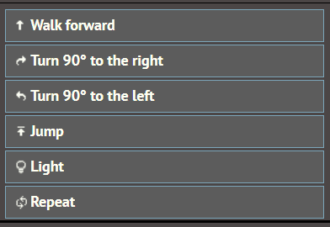

Example:

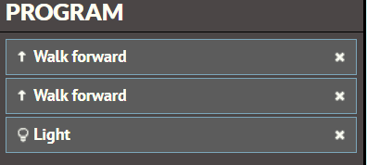

There are three steps required to complete the tasks as follows:

1. Move forward by one step
2. Move forward by one step
3. Turn on the light

Make sure that you always use the minimum number of steps required to complete the task. Write down the actions required to complete the following steps:

1. Jump up or down
2. Turn right
3. Move forward by one step
4. Turn on the light

|  |
| --- |
|  |

**Part IV – Lightbot (20pts)**

You can run the lightbot app on web browser with following URL: [Lightbot - Welcome (https://www.lightbot.lu/)](https://www.lightbot.lu/)

There are three levels as follows:

* Basic – simple problems which can be solved using sequential programming. There are eight different problems in this level.
* Procedure – in this level you will use levels to create two or more mini solutions and you will combine them to create solution for the problem. There are six different problems in this level.
* Loop – in this level you will use loops to solve the problem. There are six problems in this level.

Notes:

* There may be more than one possible solution to a problem.
* You can run the program for a level as many times as you want.
* Your first solution might not work but that is Ok! Keep working on the problem till it is solved.
* You may also test partial solution. You can add couple of steps to your solution and try to run it. If they work as expected, then you can add more steps. Run the steps as you add more steps.
* Experimenting is the key word.
* Don’t worry you will not break the system if you do something wrong.
* Try to solve the problem using minimum number of steps as possible. In other words, try to get medals.
* Document your steps using instruction like walk forward, turn right, etc. for lab credit (see below). Also, make sure to copy and paste your solution (icons) or draw the icons for each step.

**Complete 10 levels (1 to 10) of this game with at least a bronze medal for each level, and fill out the steps (program instructions) for each level in the table below:**

|  |  |
| --- | --- |
| **Level** | **Steps** |
| **0** |  |
| **1** |  |
| **2** |  |
| **3** |  |
| **4** |  |
| **5** |  |
| **6** |  |
| **7** |  |
| **8** |  |
| **9** |  |
| **10** |  |

**Take a screenshot of your completed levels and paste it here.**

|  |  |
| --- | --- |
| **Level** | **Steps** |
| **1** | **5** |
| **2** | 10 |
| **3** | 5 |
| **4** | 8 |
| **5** | 10 |
| **6** | 17 |
| **7** | 25 |
| **8** | 3 |
| **9** | 3 |
| **10** | 10 |